TASK 2: Automating CI/CD Pipeline with Jenkins

NAME: TAMILARASI P

ROLL NO: 22CSR220

STEP-1:Installation of Docker
Install the Docker using the following commands:
•
- sudo apt install docker.io
- docker –version
- sudo systemctl start docker
- sudo systemctl enable docker
- sudo systemctl status docker

STEP-2:Fork a Github Repository

Fork a copy of a GitHub repository, which will create a clone of that repository in your own
account.

STEP-3:Change the username and image name
In the deploy.sh file, update your Docker Hub username, personal access token (PAT), and
change the image name to the one you created in Docker.

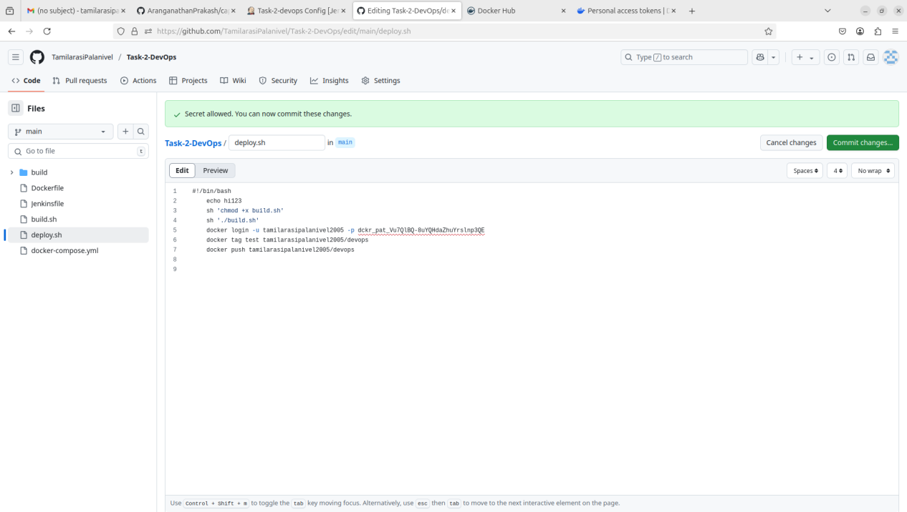

STEP-4:Create a Pipeline Job in the Jenkins

- In Jenkins, create a job using a pipeline.
- In the 'Definition' section, choose 'Pipeline script from SCM'.
- Under SCM, select 'Git', then paste the GitHub repository link in the 'Repository URL' field, which contains the script files for your job.
- Change the branch to match the one you're using in Git, and verify the filename.
- Finally, click 'OK' to proceed.

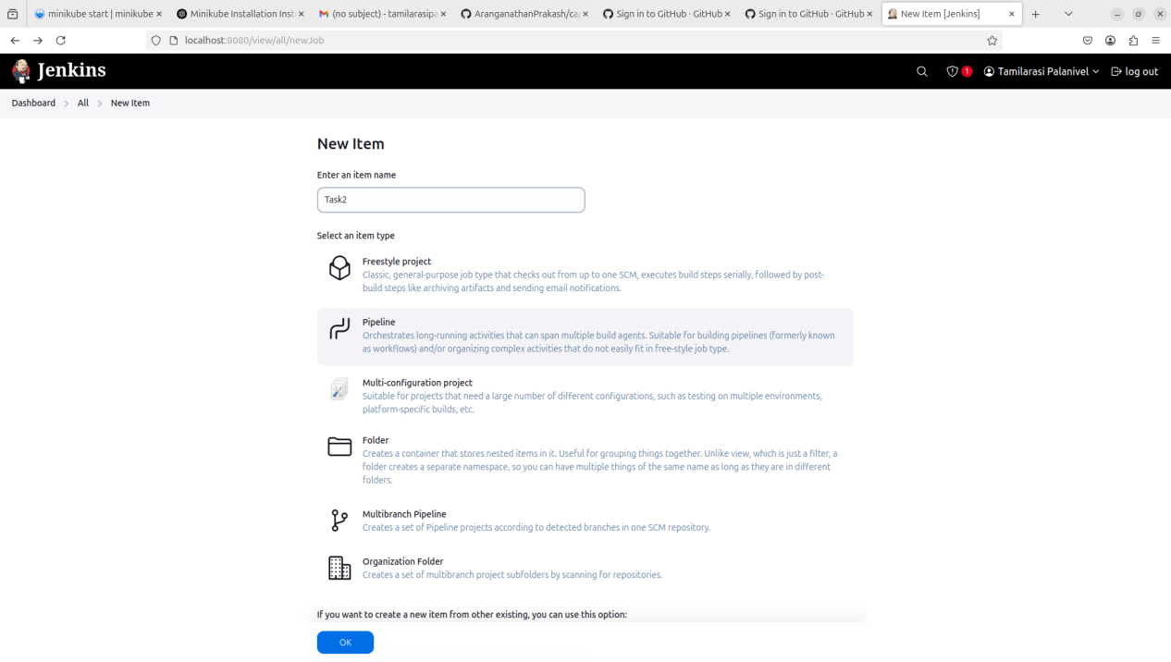

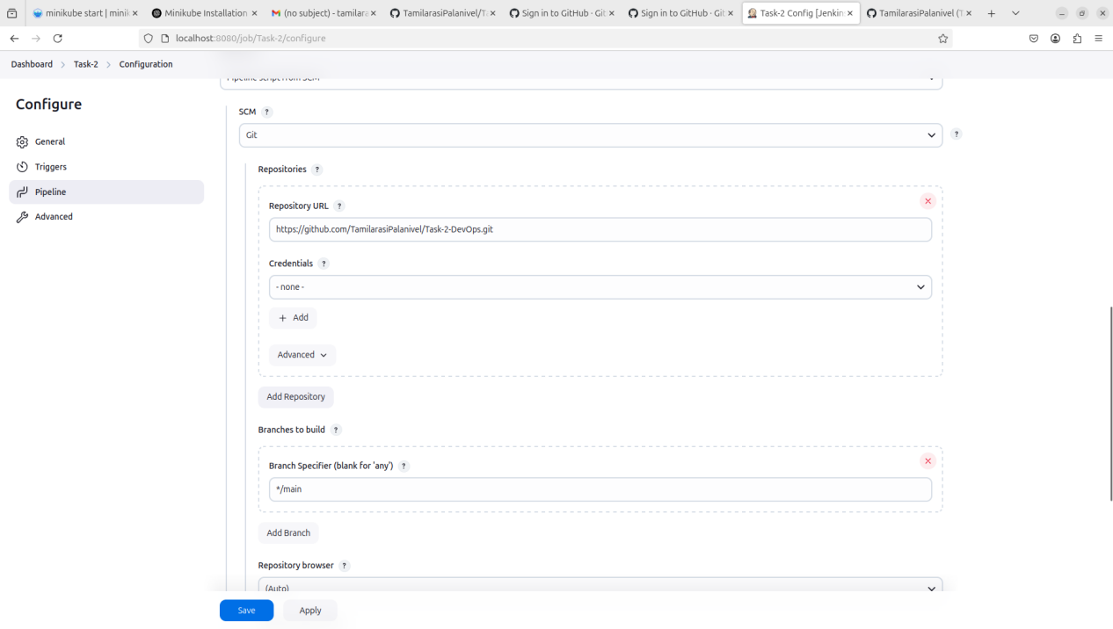
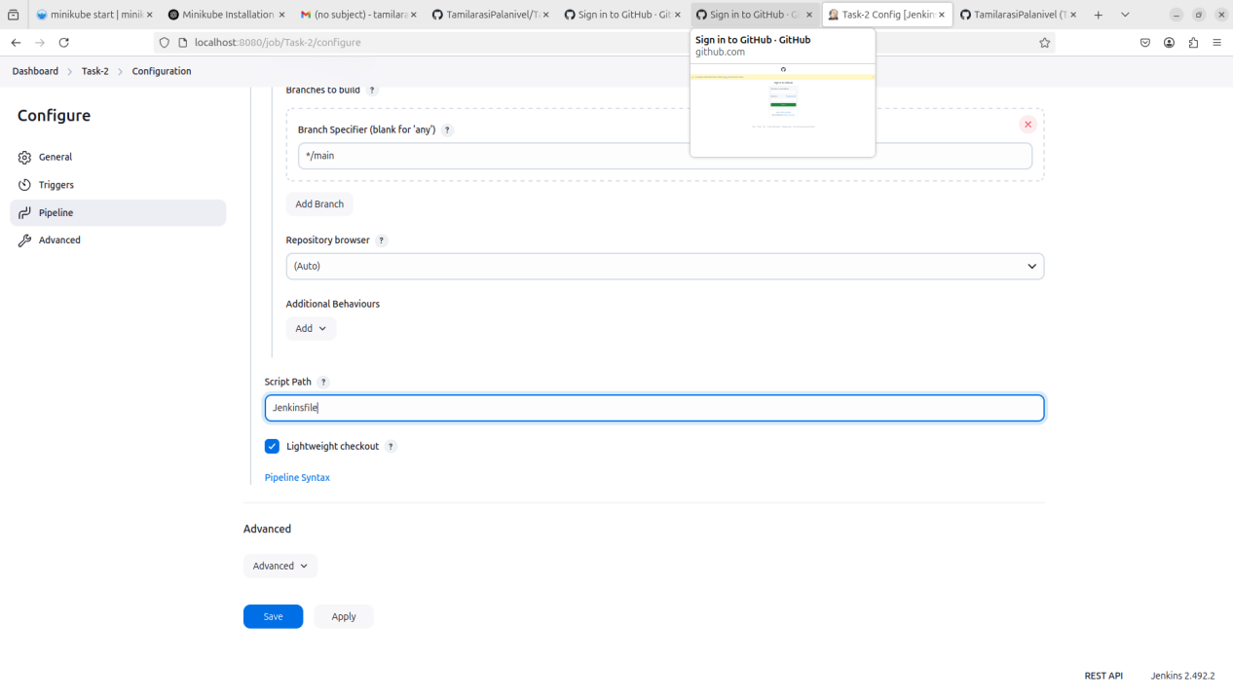
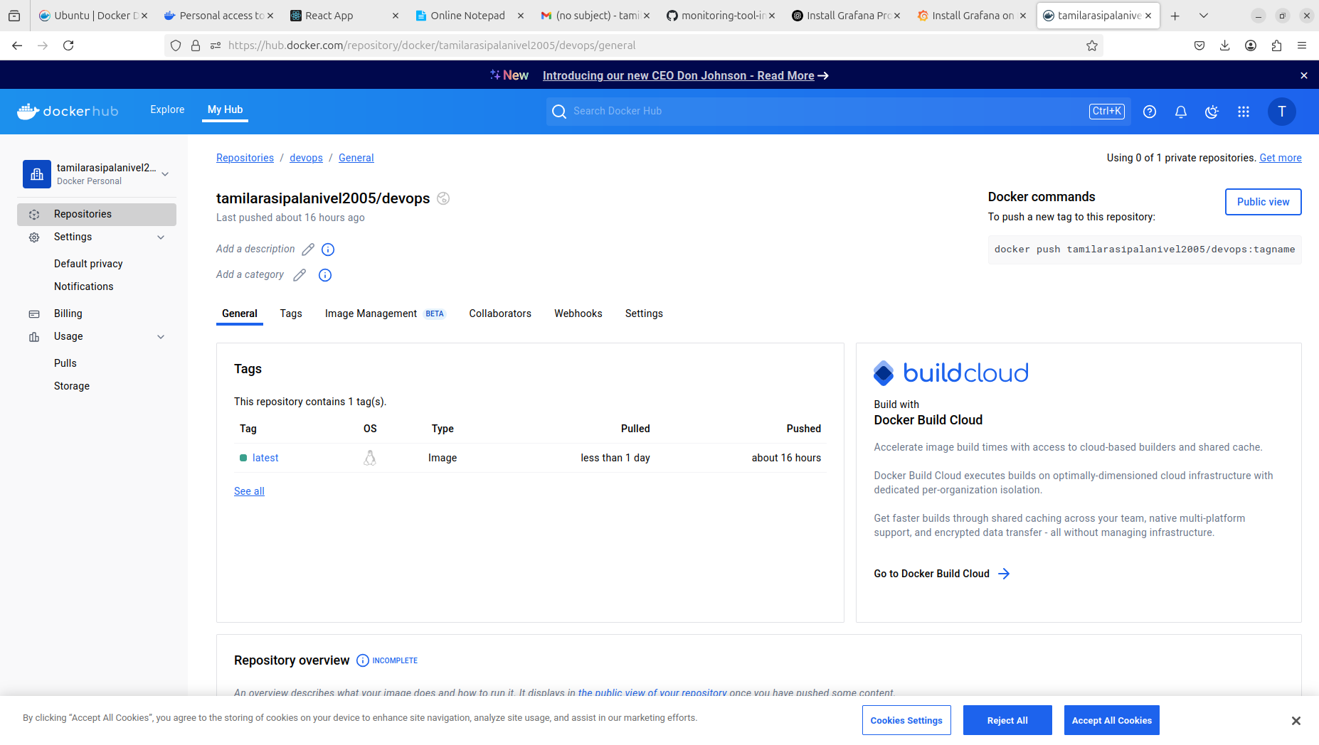

STEP-5: BUILD NOW
